- Install MangoDB databse server.
- Create a directory/folder to store MongoDB datafiles.
- Set neccessay path environment variable .
- Startup MongoDB datase.
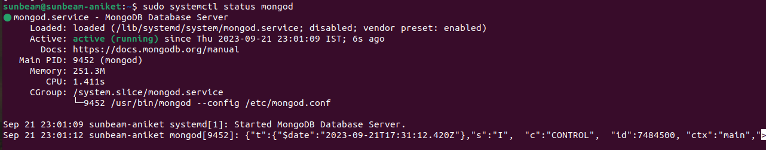
- Connect to MongoDB database through the MongoDB shell command line.

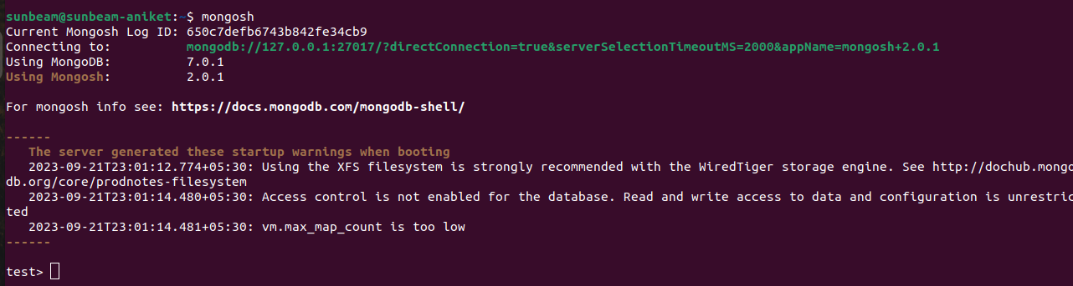
- View list of available database.

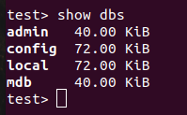

- Create a new databse named cdac and connect to it.

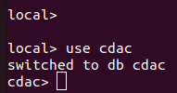

- View list of availabe collection in cdac database.

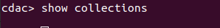

- Create a new collection by the name of LIBRARY.
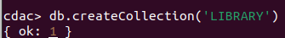

10. Insert the following doccument in the LIBRARY collection :-tiltle : ‘MangoDB Programming’author : ‘Sameer’ likes : 100

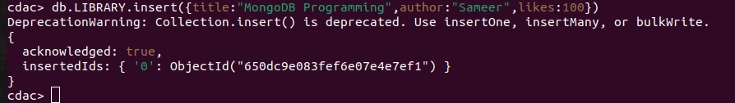

11. View the resently inserted document and note _id field.

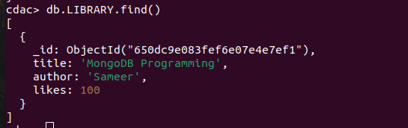

12. Insert another document in LIBRARY Collection as Follows :-
title : ‘MySQL Programming’,
authors : [‘Jack’,’Jill’], Likes : 200.
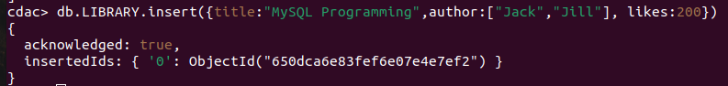

13. View the inserting doccuments.

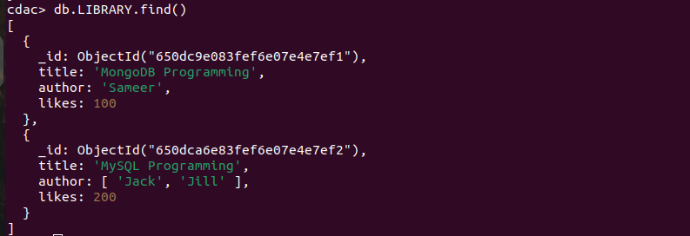

14. View only first inserted doccument.

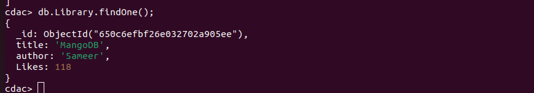

15. View the documents using Pritty method.

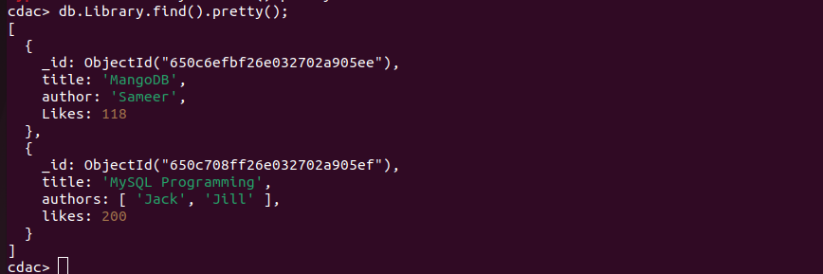
16. Update the document where author name Sameer and change it to Sameer Dehadri.
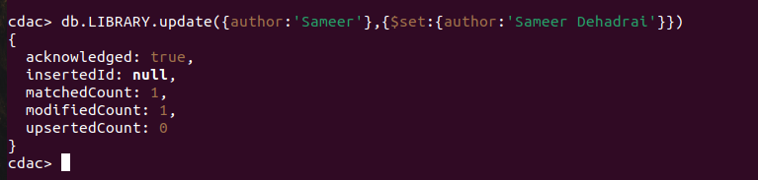

17. Delete all documents that have 100 likes.

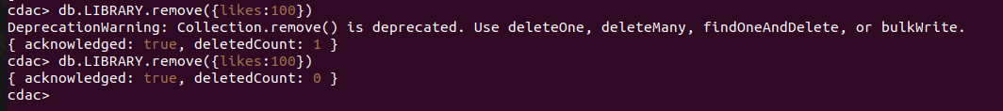

18. Drop LIBRARY collection.
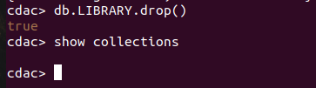

19. Drop the CDAC database.
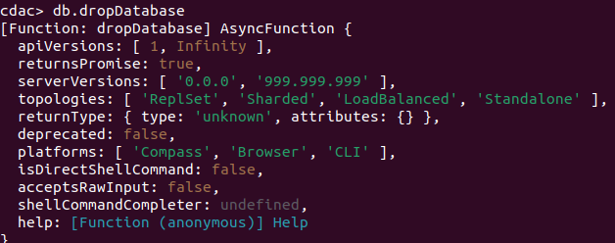
20. Exit from MongoDB shell.



21. Stop MongoDB server.

